FN: Chukwu Irele  Group: KH-218ia.e

Date: 5- 22-2020

TASK:

1. Create a database that will contain:

- a table of facts (for example, “sale of goods”, “provision of services”, “ticket issuance”, “visit to the doctor”, etc.) with the relevant fields;

- tables of dimensions that describe the entities involved in the transaction, which is described in the previous table (for example, product and buyer, service and manager, direction and passenger, doctor and patient, etc.);

- a table of time dimension, which will have fields for the date as a whole, year, month, including in text form in several languages, day, quarter, etc.

Link the tables so that a “star” schema is formed. If necessary, you can create a “snowflake” scheme.

2. Fill in the dimension tables and the fact table respectively, by creating at least 5 records in each of the tables.

To fill in the tables, write INSERT INTO queries, use certain DBMS date and time functions to fill in the time dimension table.

3. Create a SELECT query to get all records from the fact table, linking it to the rest of the tables so that you can get meaningful information about the business processes in discussion.

4. Prepare a text document depicting the structure of the created database, the code for INSERT INTO and SELECT queries, the results of data extraction (point 3).

Solution :

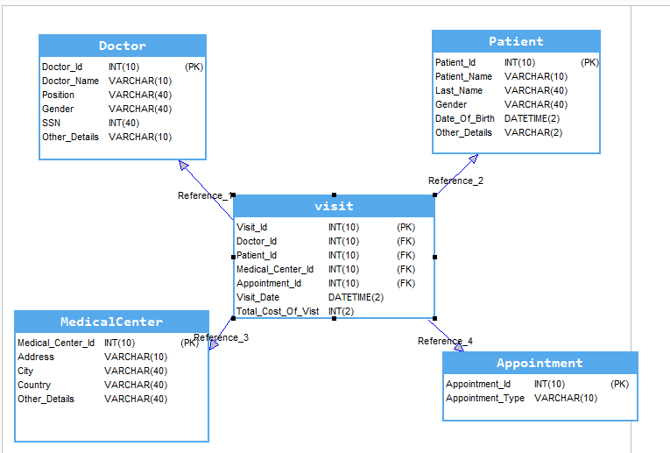

INSERT STATEMENT

Doctor Table :

INSERT dbo.Doctor

(

Doctor_Id,

Doctor_Name,

Position,

Gender,

SSN,

Other_Details

)

VALUES

( 1, -- Doctor_Id - int

'Mike Donald', -- Doctor_Name - varchar(50)

'Dentist', -- Position - varchar(50)

'Male', -- Gender - text

124256, -- SSN - int

'not available' -- Other_Details - varchar(50)

),

( 2, -- Doctor_Id - int

'Frank Jhonson', -- Doctor_Name - varchar(50)

'Therapist', -- Position - varchar(50)

'Male', -- Gender - text

569635, -- SSN - int

'not available' -- Other_Details - varchar(50)

),

( 3, -- Doctor_Id - int

'Sophia Davis', -- Doctor_Name - varchar(50)

'Physician', -- Position - varchar(50)

'Female', -- Gender - text

457936, -- SSN - int

'' -- Other_Details - varchar(50)

),

( 4, -- Doctor_Id - int

'Olivia Lopez', -- Doctor_Name - varchar(50)

'Diagnostic Medical Sonographer', -- Position - varchar(50)

'Female', -- Gender - text

976535, -- SSN - int

'' -- Other_Details - varchar(50)

),

( 5, -- Doctor_Id - int

'Adams Baker', -- Doctor_Name - varchar(50)

'Pharmacist', -- Position - varchar(50)

'Male', -- Gender - text

526475, -- SSN - int

'' -- Other_Details - varchar(50)

)

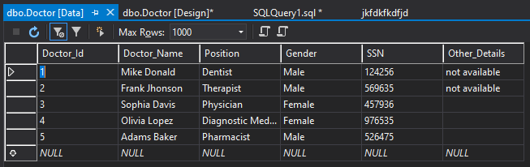

Appointments :

INSERT dbo.Appointment

(

Appointment_Id,

Appointment_Type

)

VALUES

( 1, -- Appointment_Id - int

'Routine checkup' -- Appointment_Type - varchar(50)

),

( 2, -- Appointment_Id - int

'Suggery' -- Appointment_Type - varchar(50)

),

( 3, -- Appointment_Id - int

'Marternity scan' -- Appointment_Type - varchar(50)

),

( 4, -- Appointment_Id - int

'Vaccinations' -- Appointment_Type - varchar(50)

),

( 5, -- Appointment_Id - int

'Mammograms' -- Appointment_Type - varchar(50)

)

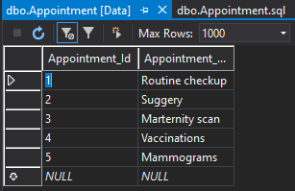

Patient :

INSERT dbo.Patient

(

Patient_Id,

Patient_Name,

Last_Name,

Gender,

Date_Of_Birth,

Other_Details

)

VALUES

( 1, -- Patient_Id - int

'Dela ', -- Patient_Name - varchar(50)

'Cruz', -- Last_Name - varchar(50)

'Female', -- Gender - varchar(50)

1953-01-01, -- Date_Of_Birth - datetime

'' -- Other_Details - varchar(50)

),

( 2, -- Patient_Id - int

'Smith James', -- Patient_Name - varchar(50)

'James', -- Last_Name - varchar(50)

'Male', -- Gender - varchar(50)

1993-01-01, -- Date_Of_Birth - datetime

'' -- Other_Details - varchar(50)

),

( 3, -- Patient_Id - int

'Jane ', -- Patient_Name - varchar(50)

'Jones', -- Last_Name - varchar(50)

'Female', -- Gender - varchar(50)

1999-02-07, -- Date_Of_Birth - datetime

'' -- Other_Details - varchar(50)

),

( 4, -- Patient_Id - int

'Sarah ', -- Patient_Name - varchar(50)

'Smith', -- Last_Name - varchar(50)

'Female', -- Gender - varchar(50)

1993-09-07, -- Date_Of_Birth - datetime

'' -- Other_Details - varchar(50)

),

( 5, -- Patient_Id - int

'Lee ', -- Patient_Name - varchar(50)

'Brown', -- Last_Name - varchar(50)

'Female', -- Gender - varchar(50)

1997-06-01, -- Date_Of_Birth - datetime

'' -- Other_Details - varchar(50)

)

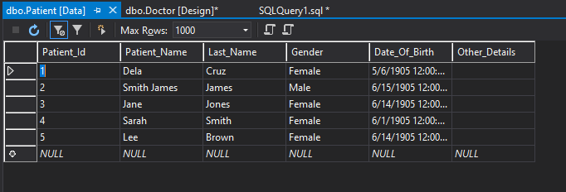

Medical Center:

INSERT dbo.MedicalCenter

(

Medical_Center_Id,

Address,

City,

Country,

Other_Details

)

VALUES

( 1, -- Medical_Center_Id- int

'454 NW. San Juan St.Clemmons, NC 27012', -- Address - varchar(50)

'İzmir', -- City - varchar(50)

'Turkey', -- Country - varchar(50)

'' -- Other_Details - varchar(50)

),

( 2, -- Medical_Center_Id - int

'8388 Amherst Ave. Marcus Hook, PA 19061', -- Address - varchar(50)

'Recife', -- City - varchar(50)

'Brazil', -- Country - varchar(50)

'' -- Other_Details - varchar(50)

),

( 3, -- Medical_Center_Id - int

'7449 East Drive Drexel Hill, PA 19026', -- Address - varchar(50)

'Toronto', -- City - varchar(50)

'Canada', -- Country - varchar(50)

'' -- Other_Details - varchar(50)

),

( 4, -- Medical_Center_Id - int

'8579 East Ridgeview Street Fayetteville, NC 28303', -- Address - varchar(50)

'Kawasaki', -- City - varchar(50)

'Japan', -- Country - varchar(50)

'' -- Other_Details - varchar(50)

),

( 5, -- Medical_Center_Id - int

'58 Cedar Swamp Ave. Decatur, GA 30030', -- Address - varchar(50)

'Daegu', -- City - varchar(50)

'South Africa', -- Country - varchar(50)

'' -- Other_Details - varchar(50)

)

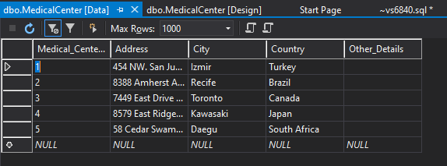

VISIT:

INSERT dbo.visit

(

Visit_Id,

Doctor_Id,

Appointment_Id,

Patient_Id,

Medical_Center_Id,

Visit_Date,

Total_Cost_Of_Vist

)

VALUES

( 1, -- Visit_Id - int

2, -- Doctor_Id - int

3, -- Appointment_Id - int

2, -- Patient_Id - int

5, -- Medical_Center_Id - int

GETDATE(), -- Visit_Date - datetime

234 -- Total_Cost_Of_Vist - money

),

( 2, -- Visit_Id - int

4, -- Doctor_Id - int

2, -- Appointment_Id - int

1, -- Patient_Id - int

4, -- Medical_Center_Id - int

GETDATE(), -- Visit_Date - datetime

150 -- Total_Cost_Of_Vist - money

),

( 3, -- Visit_Id - int

1, -- Doctor_Id - int

3, -- Appointment_Id - int

4, -- Patient_Id - int

3, -- Medical_Center_Id - int

GETDATE(), -- Visit_Date - datetime

360 -- Total_Cost_Of_Vist - money

),

( 4, -- Visit_Id - int

5, -- Doctor_Id - int

4, -- Appointment_Id - int

5, -- Patient_Id - int

1, -- Medical_Center_Id - int

GETDATE(), -- Visit_Date - datetime

678 -- Total_Cost_Of_Vist - money

),

( 5, -- Visit_Id - int

3, -- Doctor_Id - int

2, -- Appointment_Id - int

3, -- Patient_Id - int

2, -- Medical_Center_Id - int

GETDATE(), -- Visit_Date - datetime

567 -- Total_Cost_Of_Vist - money

)

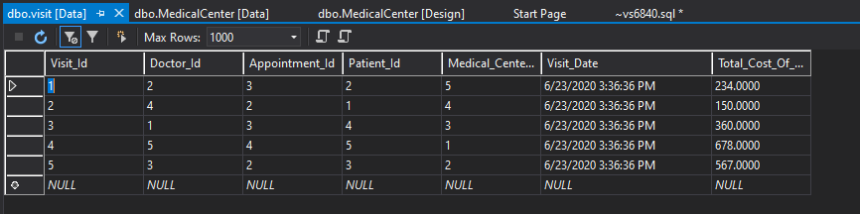

Select statement :

SELECT Visit_Id,Doctor_Name AS "Doctor Name",Position As "Doctor POSITION", SSN AS "Doctor's SSN" ,CONCAT(Patient_Name , Last_Name) AS "Patient Name" , dbo.Patient.Gender ,DATEDIFF(YY, Date_Of_Birth,GETDATE()) AS "AGE", Address AS "Medical Center" ,Appointment_Type AS "Appoitment" ,Total_Cost_Of_Vist AS "Cost of Appointment"

FROM dbo.visit,dbo.Doctor,dbo.Patient,dbo.MedicalCenter,dbo.Appointment

WHERE dbo.visit.Doctor_Id = Doctor.Doctor_Id AND dbo.Patient.Patient_Id = visit.Patient_Id AND visit.Medical_Center_Id =MedicalCenter.Medical_Center_Id AND visit.Appointment_Id=Appointment.Appointment_Id

